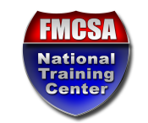
STUDENT REGISTRATION FORM

Please complete this form electronically, print it, sign and date it, and bring it with you on the first day of class. ALL fields on this form are required.

COURSE INFORMATION
Course Name:
Course Location:
(City & State)
Course Start Date:
STUDENT INFORMATION
Student Name:
(As it should appear on your certificate)
Position Title:
Organization Name:
Work Address:
Work Telephone Number:
Work Email Address:
Does your position receive Federal funding for commercial motor vehicle enforcement?
(Motor Carrier Safety Assistance Program [MCSAP] grant)
SUPERVISOR INFORMATION
Supervisor Name:
Supervisor Telephone Number:
Supervisor Email Address:

By my signature below, I certify that I have reviewed and met all prerequisites to participate in the course identified above.

Student Signature Date (MM/DD/YYYY)

